Quicktime 10 instructions.

Right now the only editing software we have is Quicktime 10 player.

You can use this software to trim your movies.

1. Drag and drop the movie you want to view on to the Quicktime player ion to open the movie.

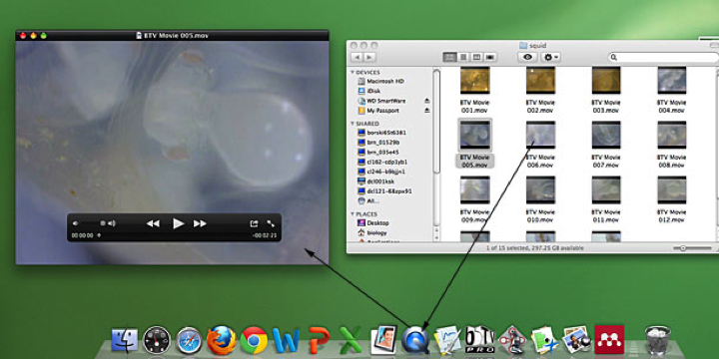

2, Select trim from the edit menu.

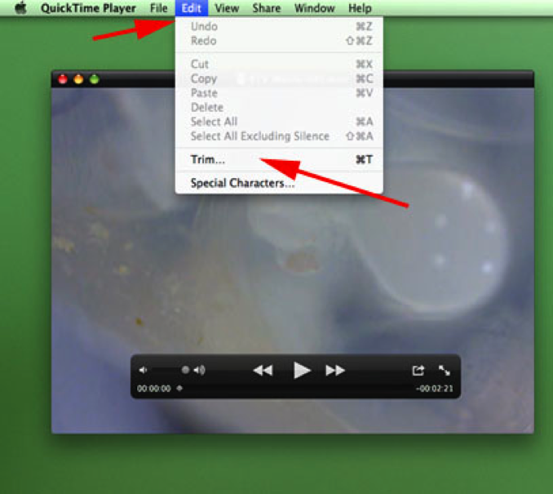

3. The trim bar will appear . Simply slide the yellow bars to contain the sequence you want to save. Everything within the yellow bars will be saved.

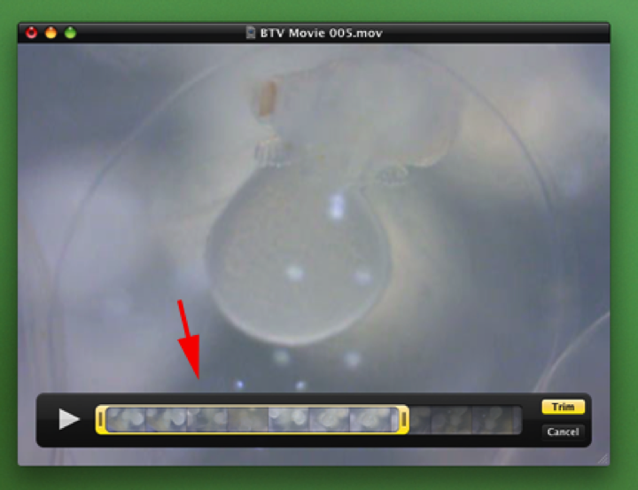

4. You can also access the trim function by clicking on the ion (see arrow) below.

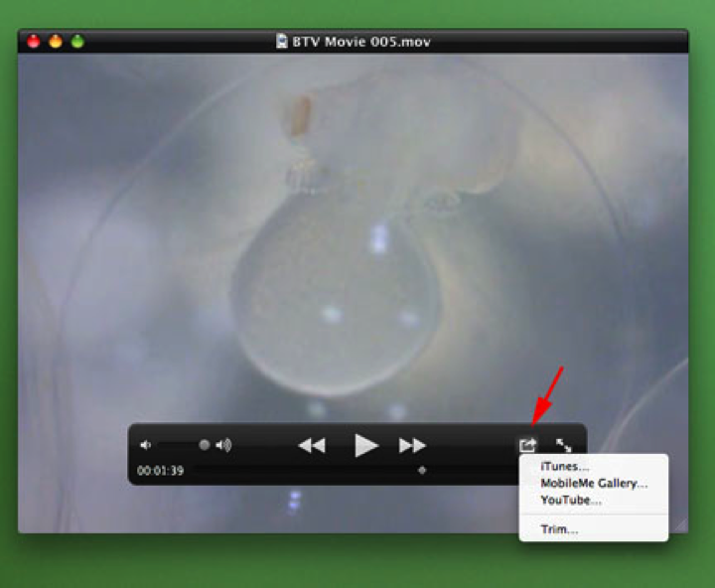

5. Trim your movie and be sure to save it under a different name.